Sliding Puzzle Framework as a building Architect
When I was small around age of 6, I remember when I was travelling from Hong Kong to Netherland. The airline I took was Royal Dutch Airland (KLM for short). I receive a kids set from the cabin crew. Inside the kids set there are toys and notebook and pencils. What makes me unforgettable is one of the toys, it is a sliding puzzle. A sliding puzzle is square puzzle, each is a rectangular piece, you need to move each piece to form the whole correct picture. This kind of sliding puzzle make me think of whether it can be applied as a framework for nowadays building structure.

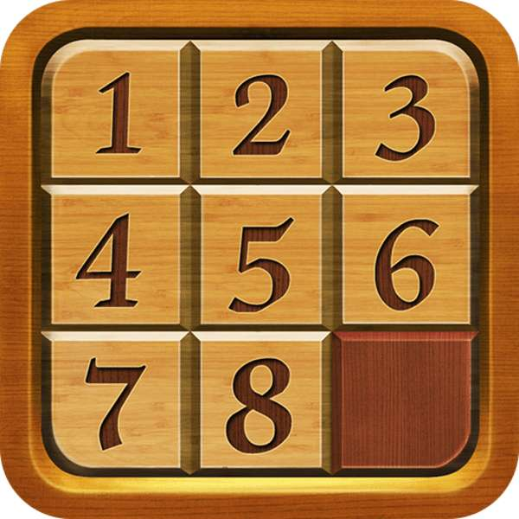
Fig. 1 a sliding puzzle

As shown on Fig. 1, this is a typical sliding puzzle. There are lots of variants; some is a picture and the one shown above is numeric. But one of the pieces must be left blank, to allow room of each piece to move up and down, left to right. Why I said this type of sliding puzzle can be a building structure framework? The main reason is first it is a flat plane, second it easy to construct and transport, third it is easy to deconstruct, as one of the pieces is left blank so removing other pieces is very easy, last, the most important it is very hard to break because it is a whole structure even disaster like earthquake and typhoon can be support.

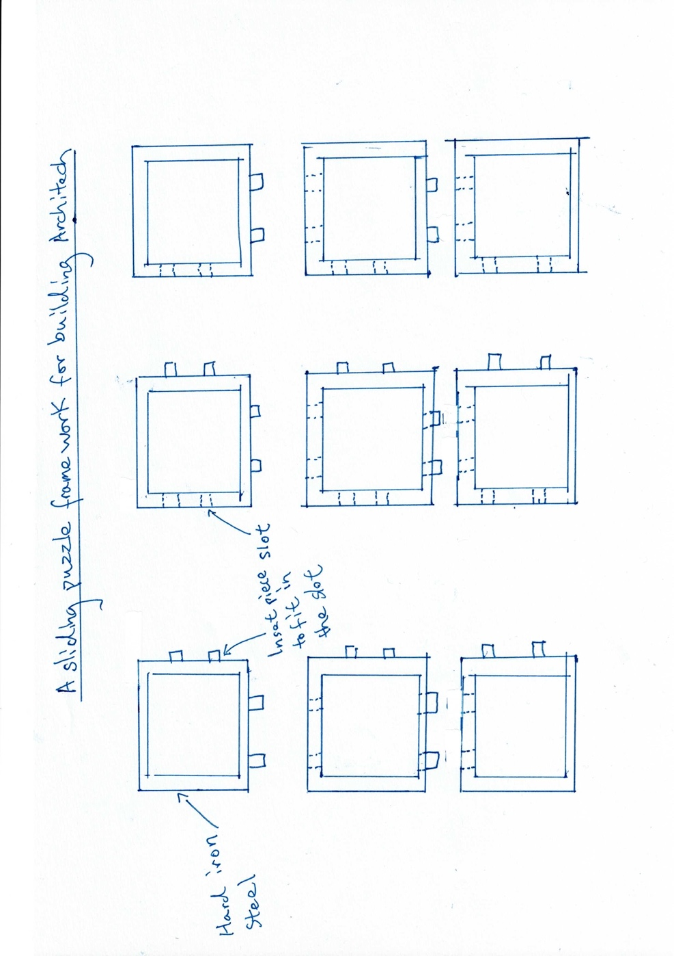
Fig. 2 a sliding puzzle framework for the building structure

Fiig. 2 is a framework for a typical building construction. Each piece is a whole structure, that means the insert piece to the slot is not weld into the iron frame. The insert piece should be as short as possible. The shorter the insert pieces the rigid it is; it is not easy or impossible to break. This is the ground construction, for the walls of the building, this also applies. For deconstruction, you just need to remove the right lower conner piece, if removed, then all pieces can easy be removed. There are several advantages of this construction, each is an individual pieces, it can be premade by any factory and transport easily to the construction site. This is not just a framework, it is encapsulated inside the cement, which can be use right away for building houses or buildings, plus it is not too heavy cause the iron framework inside area is empty only filled with cement but strong. Compared to traditional building method, construction time greatly reduce. This is because you are just construction a puzzle no additional work needs to be done. Lastly and most important. There are no such things as “主力牆” or main wall, you have more space and flexibility to design and construct rooms.

